**Lok Jagruti Kendra**

**University Course - Integrated MSc (IT)**

**BSc (IT) - Semester-I**

Subject Code :-050020204

Subject Name: - Skill Development Web Tools

RollNo :-- 08

Name of the Student:-- Pratik Chotaliya

Division : D

**Plagiarism Declaration**

To whom so ever it may concern

I/ We, the project team, confirm that this assignment is my own work, is not copied from any other person's work (published or unpublished), and has not previously submitted for assessment either at University or elsewhere. I/We confirm that I/we have read and understood the rules regulations on plagiarism in LJKU.

|  |  |  |
| --- | --- | --- |
| Enrollment no | Name | Sign |
| 21004500210194 | Pratik Chotaliya |  |

**Unit 1**

1.Introduction to Google Calendar

• Create a Calendar named “Part time Job”

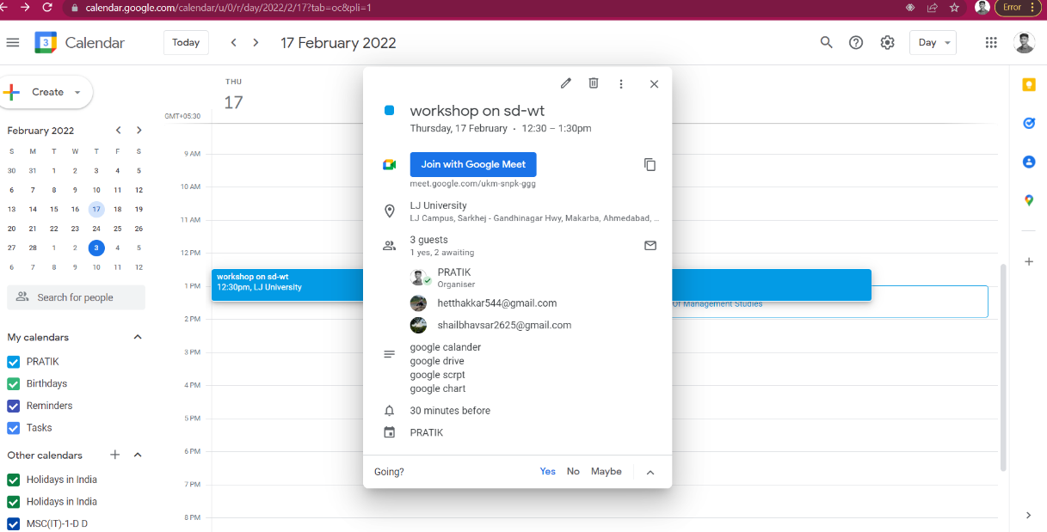

2. Introduction to Google Drive

• Create a document “About your family” and write down at least 10 to 15 lines about family.

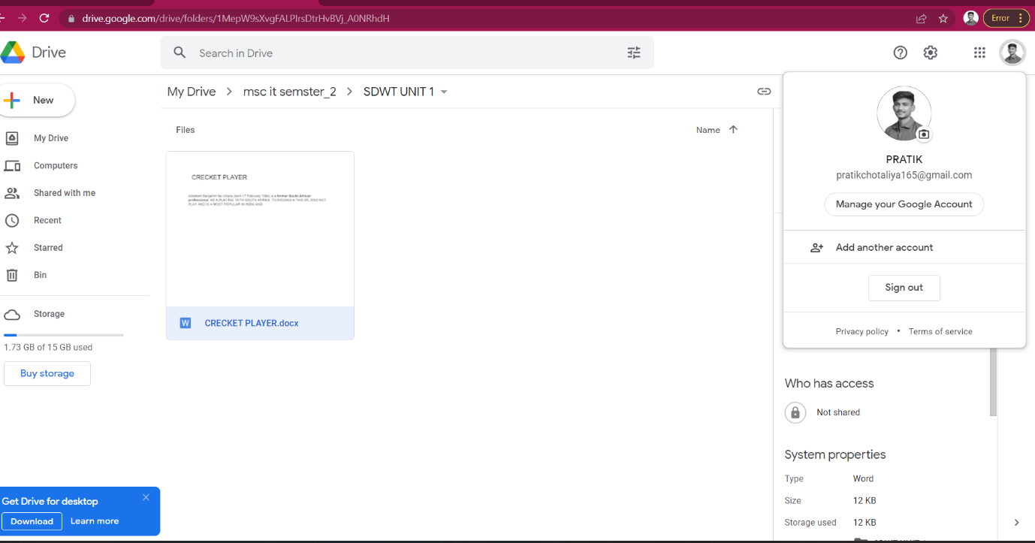

3. Introduction to Google Sheet

• Create a google sheet as following and apply conditional formatting as per the conditions. Color the “Free Parking” cells with yellow color. Share the sheet and protect the cells for changes.

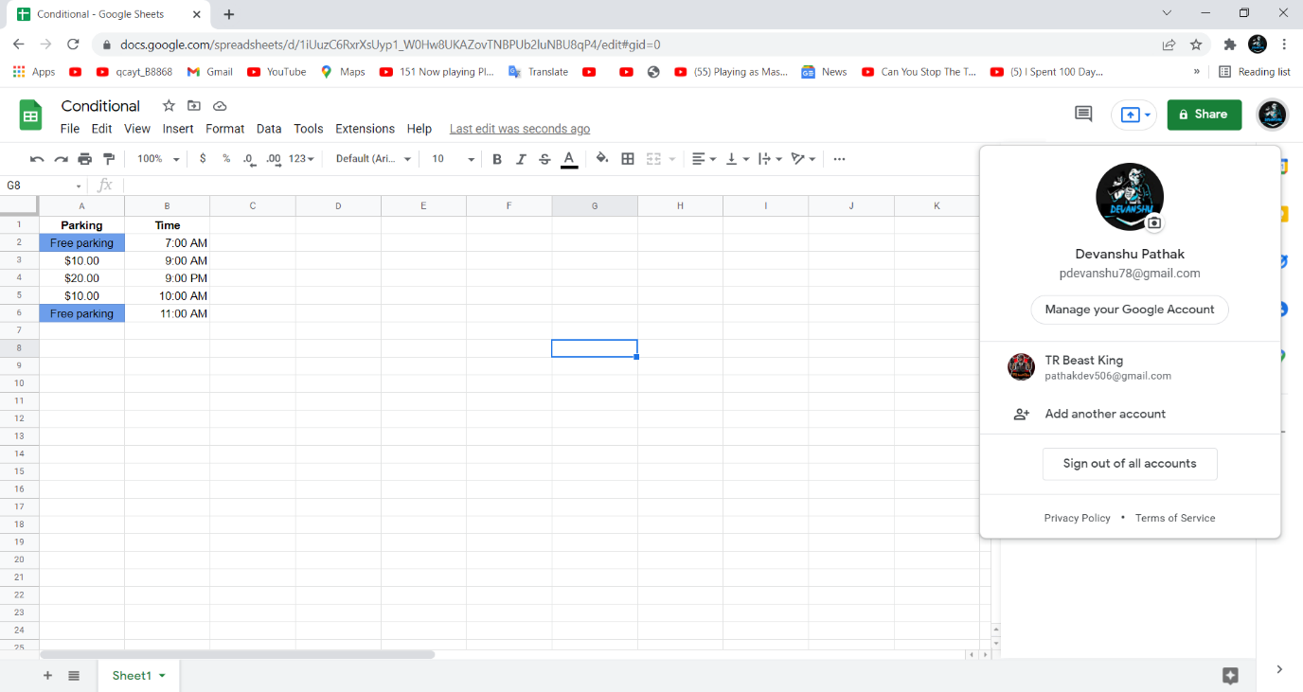

4.Introduction to Google form

• Create a google form to conduct a survey on Free Learning Apps available on market. 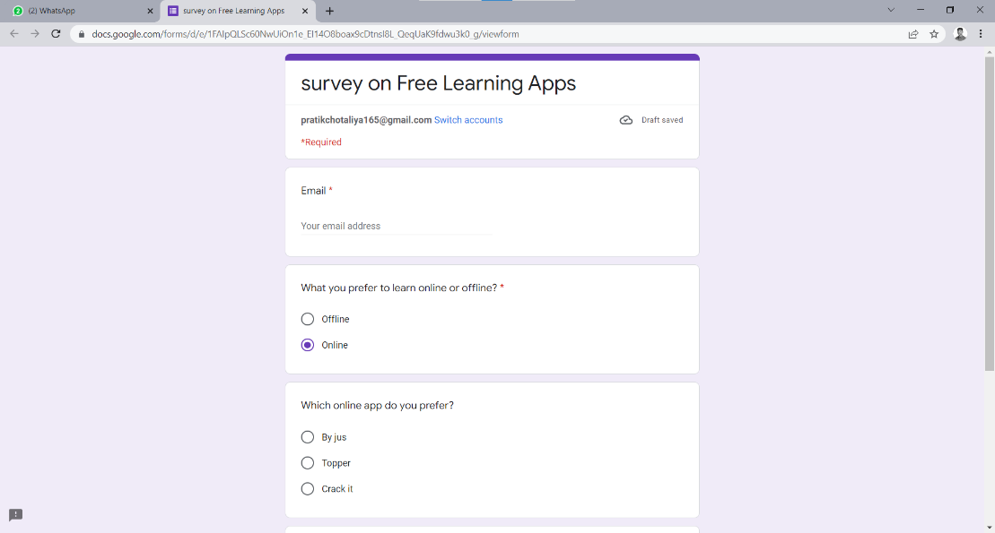

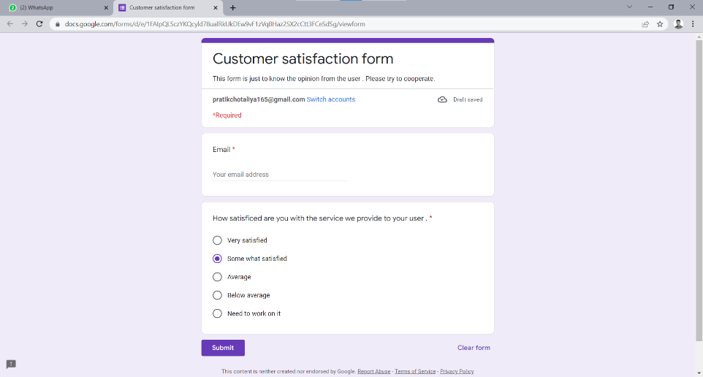

5. Introduction to Google Scripts • Create a spreadsheet titled “Demo”

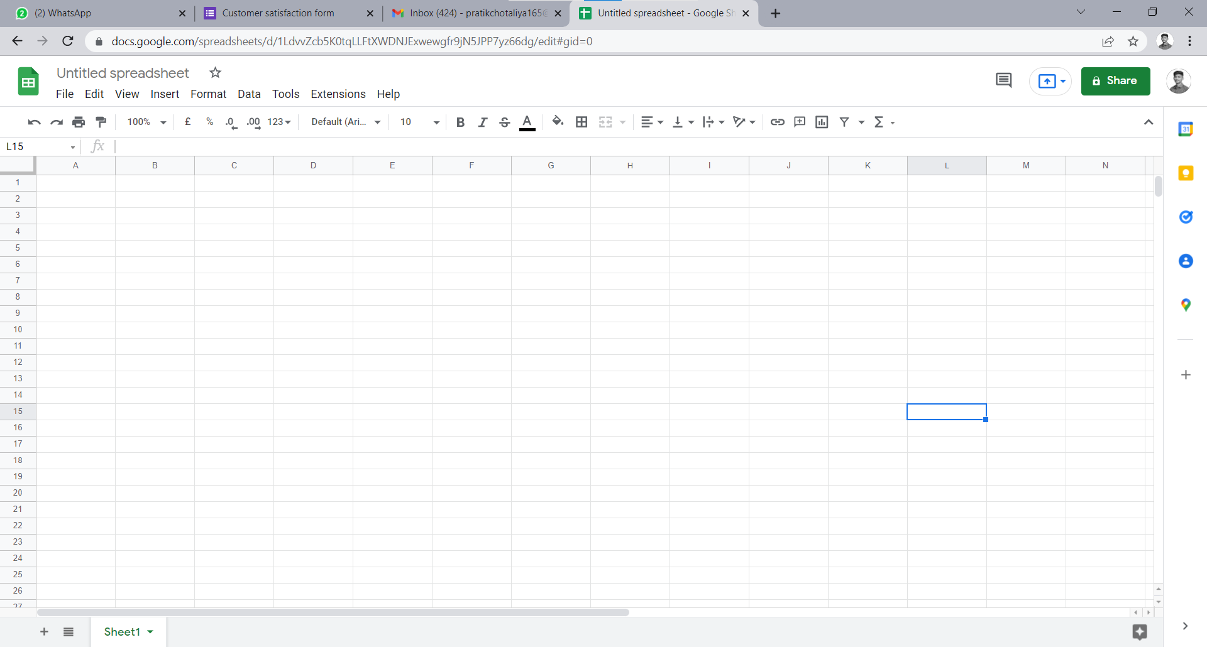

6. Introduction to Google Charts

• Incorporate Line chart and bar chart in your webpage.

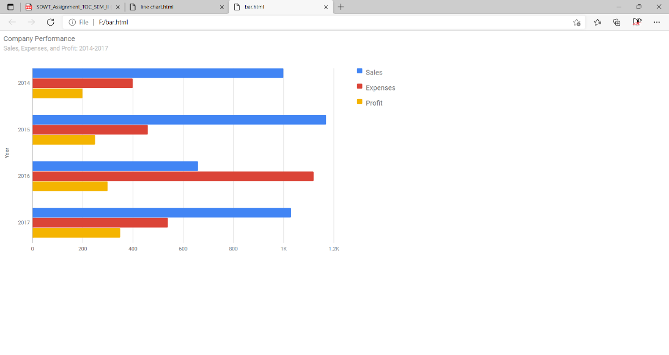

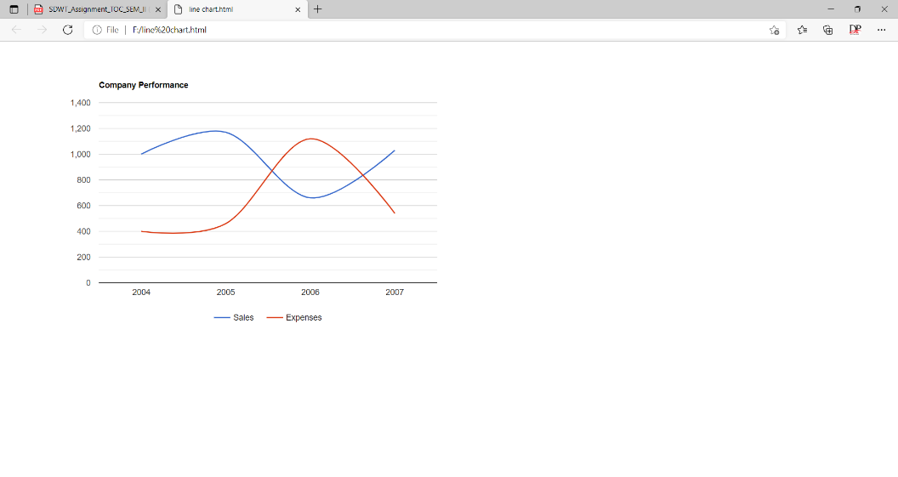

**7. Creates a Google Doc and sends an email to the current user**

**with a link to the doc.**

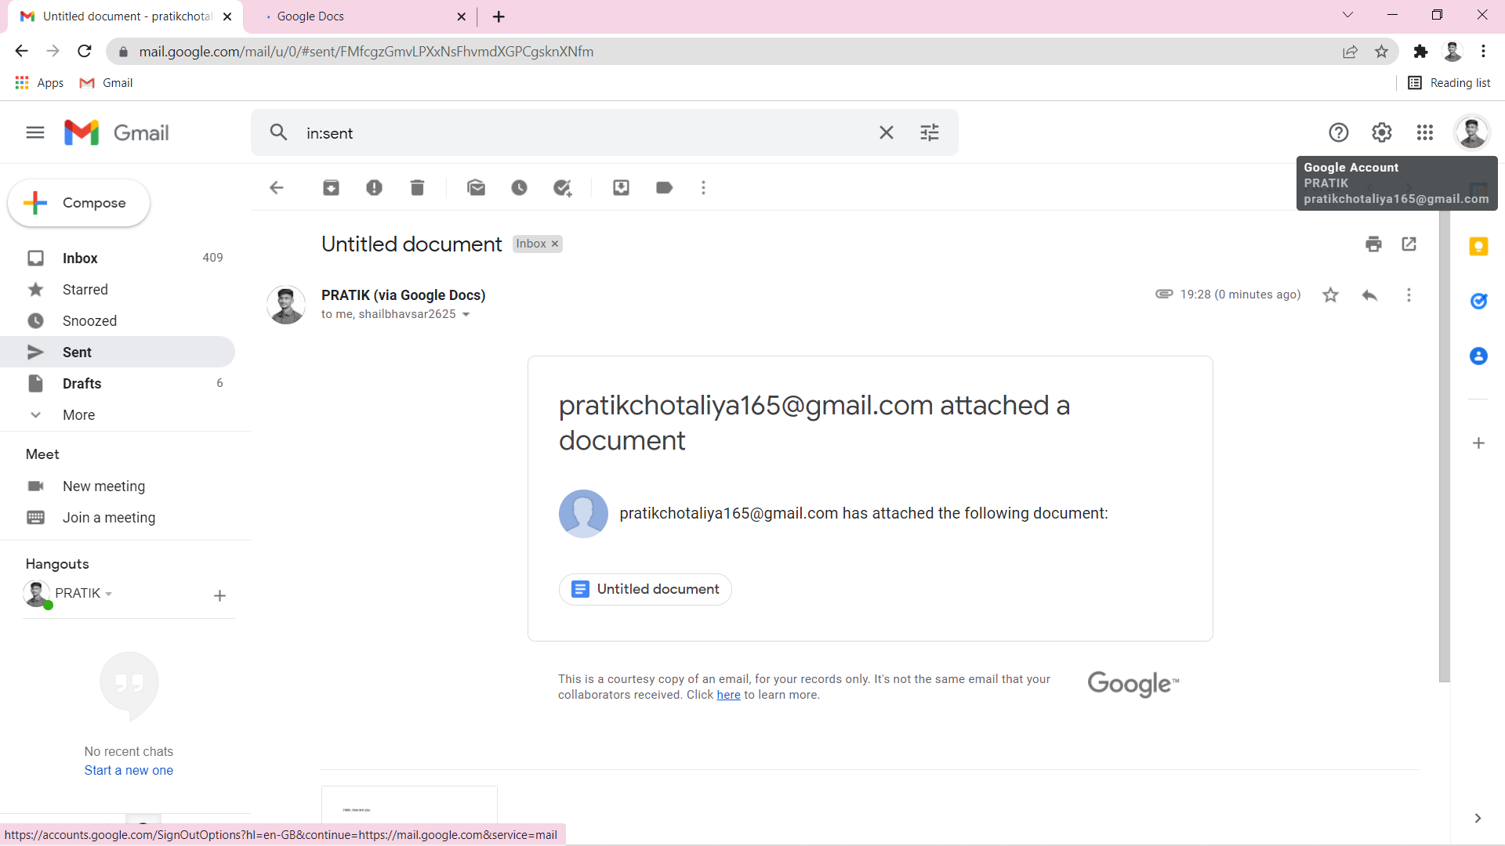

**2) Create a GAS to send an email to recipient from Sheet.**

Use HTML template for Event invitation

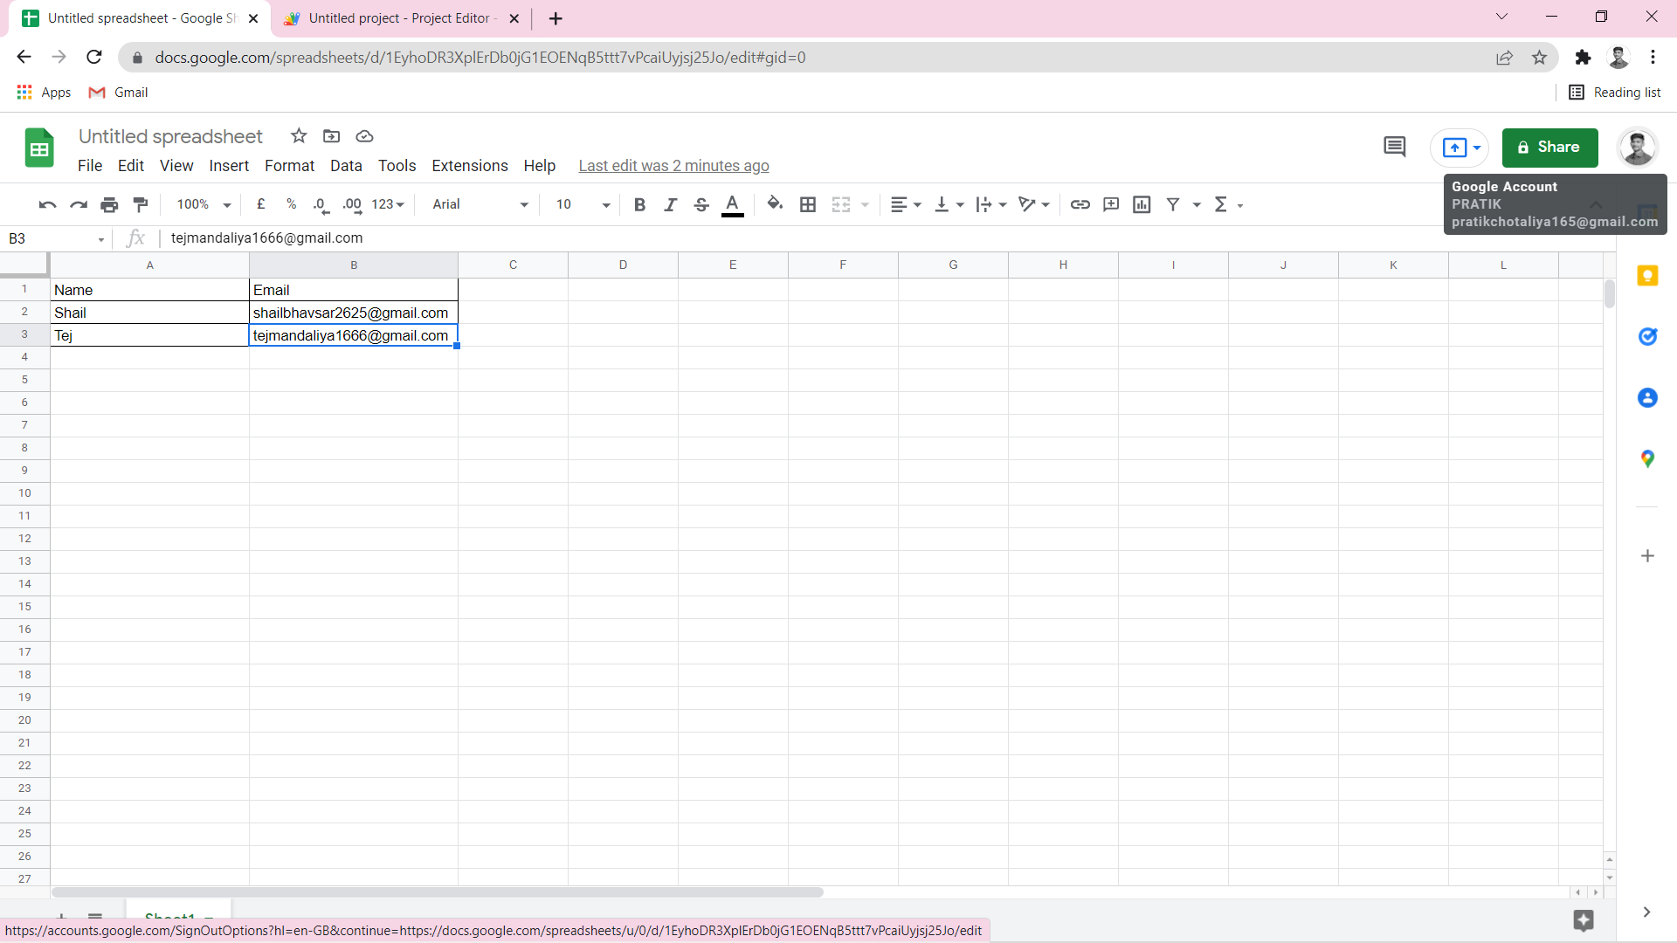

**4) Create a custom menu for data formatting**

Data Formatting

- Header Formatting

- Add summary

- Row totals

- Column Totals

- Data Formatting

- Border

- Color cell having low values

- Count cells based on color

- Flipping Your Rows & Columns

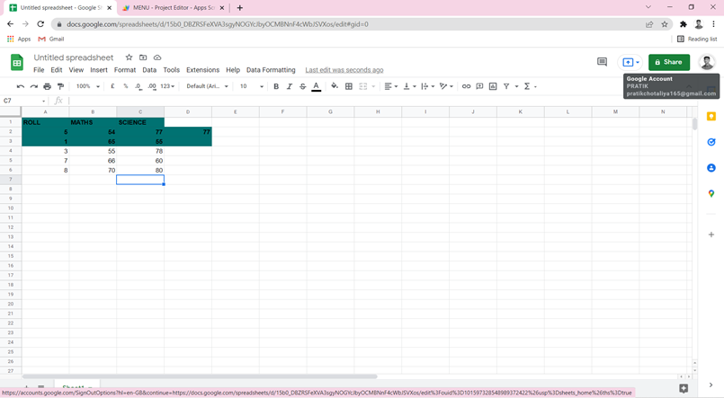

**5.) Create a WAS to send random questions from Sheet to emails**

